**Name – Jain Samkitkumar Hasmukhlal Roll. No – 20**

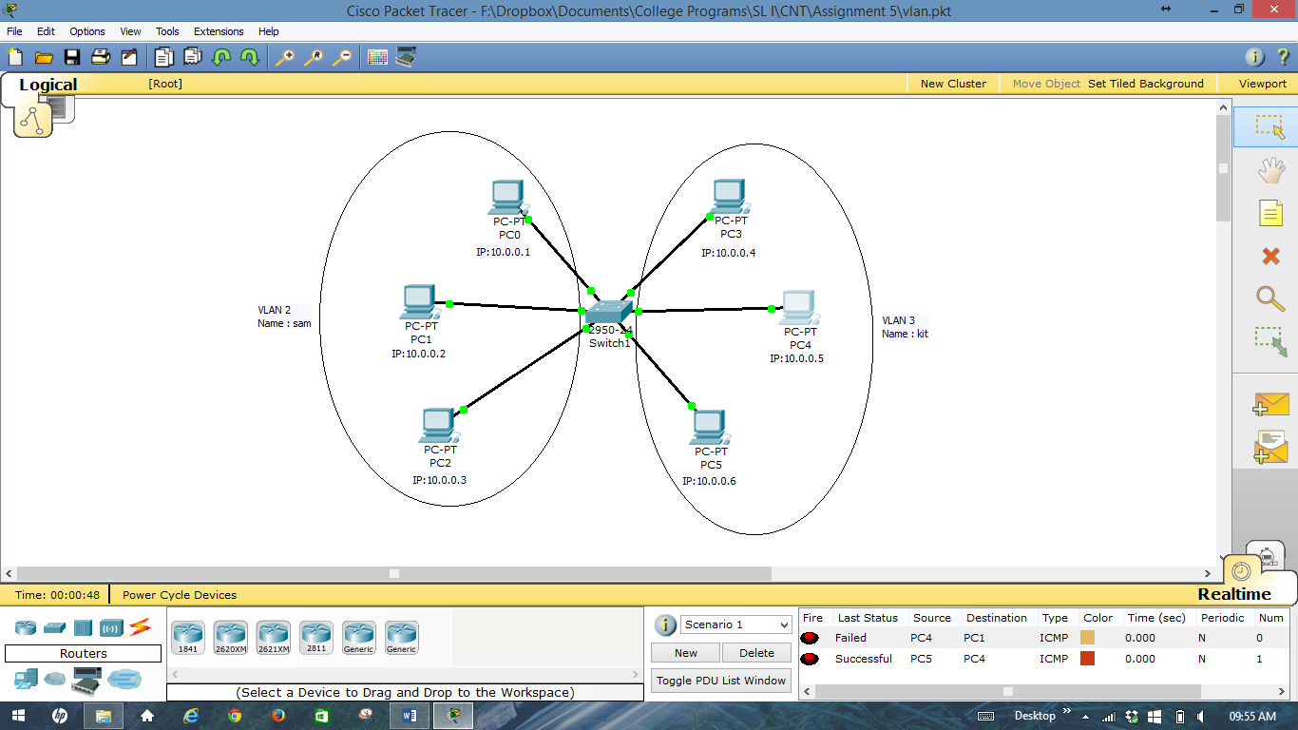

**Name – Jain Samkitkumar Hasmukhlal Roll. No – 20**

